PROJECT REPORT

MOBILE APP FOR DIRECT MARKET ACCESS FOR FARMERS

Submitted by
Subathra C
2nd year – Information Technology

1. ABSTRACT
The Mobile App for Direct Market Access for Farmers is a web-based application developed to provide a direct connection between farmers and buyers. The system allows farmers to register and log in, add their agricultural products, manage product information, view orders, and update order status.
Buyers can register and log in to the application, browse available agricultural products, search for products, add products to the cart or wishlist, place orders, select payment options, and view their orders.
The application uses Python Flask for backend development, HTML, CSS and JavaScript for the user interface, and MySQL for database management. CRUD operations are implemented for product management. The application is tested using Postman and the source code is maintained using Git and GitHub.
The project provides a simple digital platform that helps manage farmer products and buyer orders efficiently.

2. INTRODUCTION
Agricultural products often pass through multiple intermediaries before reaching customers. This can make product management and direct selling difficult for farmers. Buyers may also find it difficult to identify available products, prices, quantities, and order information.
The proposed Mobile App for Direct Market Access for Farmers provides a digital platform where farmers can manage their products and buyers can directly browse and purchase them.
The application provides separate interfaces for:
- Farmer
- Buyer
- Administrator
The project follows the CRUD-based application development approach. CRUD stands for:
- Create
- Read
- Update
- Delete
CRUD functionality is an important part of the project because the SOP requires all four operations to be implemented and demonstrated.

3. PROBLEM STATEMENT
Traditional agricultural product selling can involve intermediaries and manual processes. Farmers may face difficulties in managing product information, stock, prices, and customer orders.
Buyers may also need a convenient method to:
- View available products
- Search products
- Check prices and stock
- Place orders
- Track order status
- Manage cart and wishlist
Therefore, a web-based application is developed to provide a centralized platform for farmers, buyers, and administrators.

4. OBJECTIVES
The main objectives of the project are:
- To develop a web application for direct farmer-to-buyer interaction.
- To allow farmers to register and securely log in.
- To allow farmers to add and manage agricultural products.
- To implement Create, Read, Update and Delete operations.
- To allow buyers to browse available products.
- To provide cart and wishlist functionality.
- To allow buyers to place orders.
- To provide order management for farmers and administrators.
- To maintain product and user information using MySQL.
- To test application functionality using Postman.
- To maintain the project source code using Git and GitHub.
The SOP identifies CRUD implementation, database integration, validation, testing, documentation and version control as key parts of a complete application.

5. SCOPE OF THE PROJECT
The scope of the application includes:
Farmer Module
- Farmer registration
- Farmer login
- Farmer dashboard
- Add products
- View products
- Edit products
- Delete products
- View orders
- Accept/reject orders
- Update order status
- View sales information
Buyer Module
- Buyer registration
- Buyer login
- Buyer dashboard
- View products
- Search products
- Add products to cart
- Add products to wishlist
- Place orders
- Checkout
- View orders
- Add reviews and ratings
- View invoice

Admin Module
- Admin login
- Admin dashboard
- View farmers
- View buyers
- View products
- View orders
- Delete farmer/buyer/product records
- View sales reports

6. EXISTING SYSTEM
In a traditional system, farmers may depend on local markets or intermediaries to sell agricultural products.
Limitations
- Limited direct interaction between farmers and buyers
- Manual product management
- Difficult stock management
- Manual order tracking
- Limited product visibility
- Difficult record maintenance
- Less centralized information

7. PROPOSED SYSTEM
The proposed system provides an online platform for managing agricultural products and orders.
Farmers can directly manage their products and buyers can browse and purchase available products.
Advantages
- Direct farmer-to-buyer interaction
- Easy product management
- Online product browsing
- Stock management
- Cart and wishlist functionality
- Online order placement
- Order status management
- Review and rating functionality
- Centralized database
- CRUD-based product management

8. TECHNOLOGY USED
Component | Technology
Frontend | HTML
Styling | CSS
Client-side scripting | JavaScript
Backend | Python Flask
Database | MySQL
Database Connector | mysql-connector-python
API Testing | Postman
Version Control | Git
Repository | GitHub
Development Environment | Visual Studio Code
The SOP allows modern frontend technologies, backend frameworks, databases, Postman and Git/GitHub for this type of project.

9. SYSTEM REQUIREMENTS
9.1 Hardware Requirements
- Computer/Laptop
- Minimum 4 GB RAM
- Minimum 10 GB available storage
- Internet connection
9.2 Software Requirements
- Windows OS
- Python
- Flask
- MySQL Server
- MySQL Connector
- Visual Studio Code
- Postman
- Web Browser
- Git

10. SYSTEM ARCHITECTURE
The application follows a three-layer architecture.
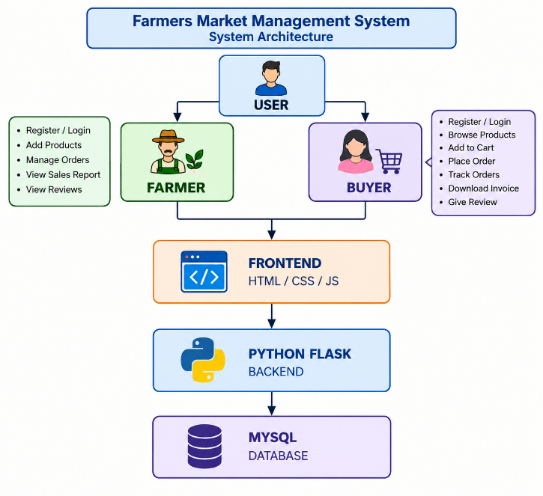

Data Flow
User → Frontend → Flask Backend → MySQL Database
The SOP describes the general full-stack flow as user interface → backend/API → database, with CRUD operations handled through the backend.
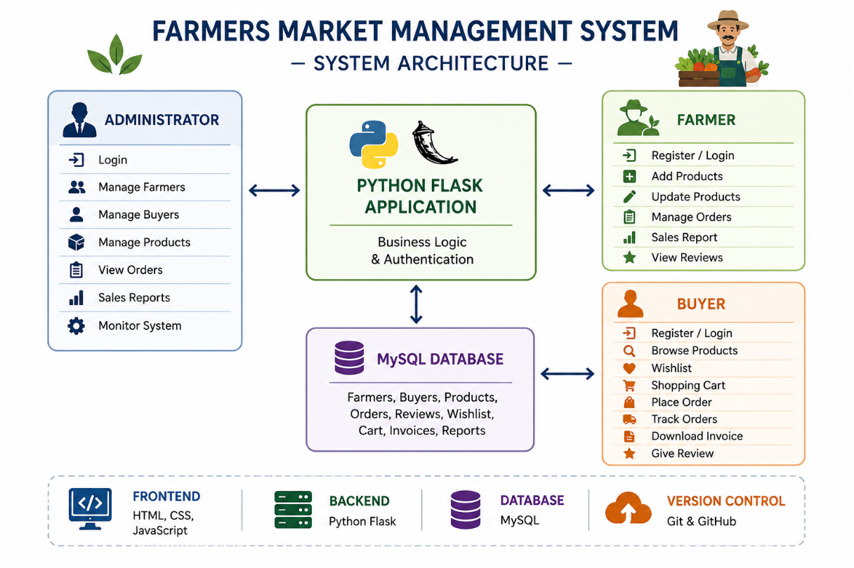
System Architecture of Farmers Market Application

11. MODULE DESCRIPTION
11.1 Farmer Module
The Farmer module allows farmers to create an account and manage their agricultural products.
Functions:
- Registration
- Login
- Dashboard
- Add product
- View product
- Edit product
- Delete product
- View orders
- Manage order status
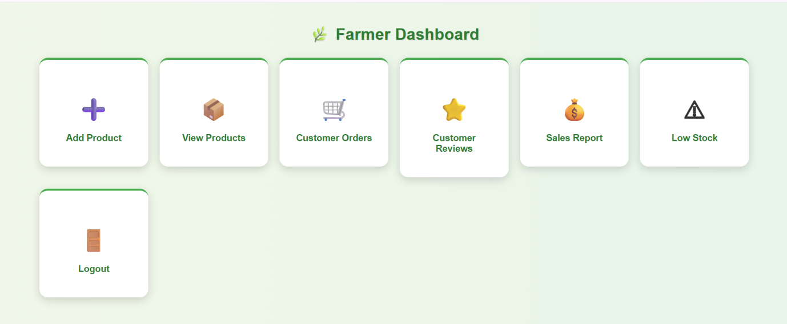
Farmer Module

11.2 Buyer Module
The Buyer module allows customers to browse and purchase agricultural products.
Functions:
- Registration
- Login
- Product browsing
- Product search
- Add to cart
- Wishlist
- Checkout
- Order placement
- Order tracking
- Reviews and ratings
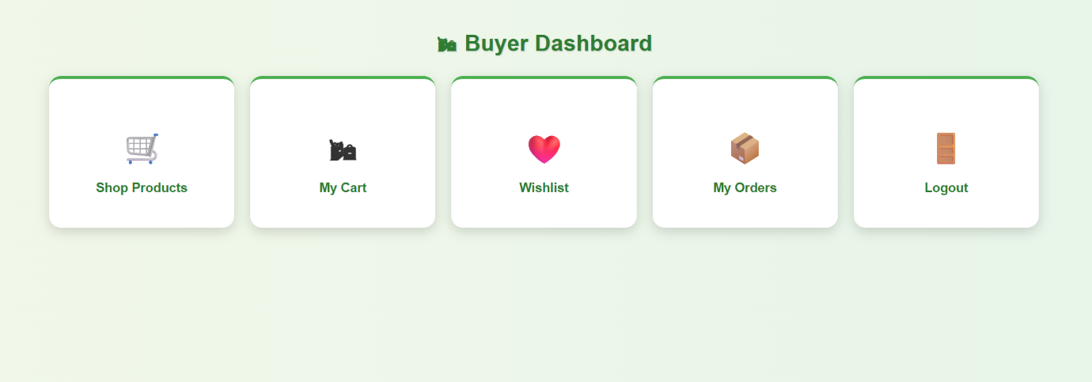
Buyer Module

11.3 Admin Module
The Admin module provides management functions for the application.
Functions:
- Admin login
- View farmers
- View buyers
- View products
- View orders
- Delete records
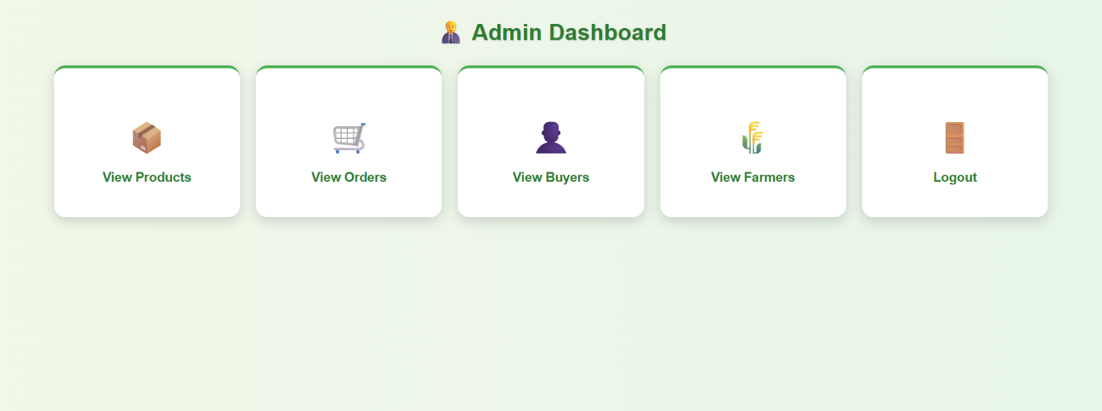
Admin Module

12. DATABASE DESIGN
The application uses MySQL as the database.
Major entities include:
- Farmer
- Buyer
- Product
- Order
- Cart
- Wishlist
- Review
The database design identifies entities, attributes, primary keys, relationships and constraints as part of the database development process.

13. ER DIAGRAM
You should create an ER diagram showing the relationships between the major entities.
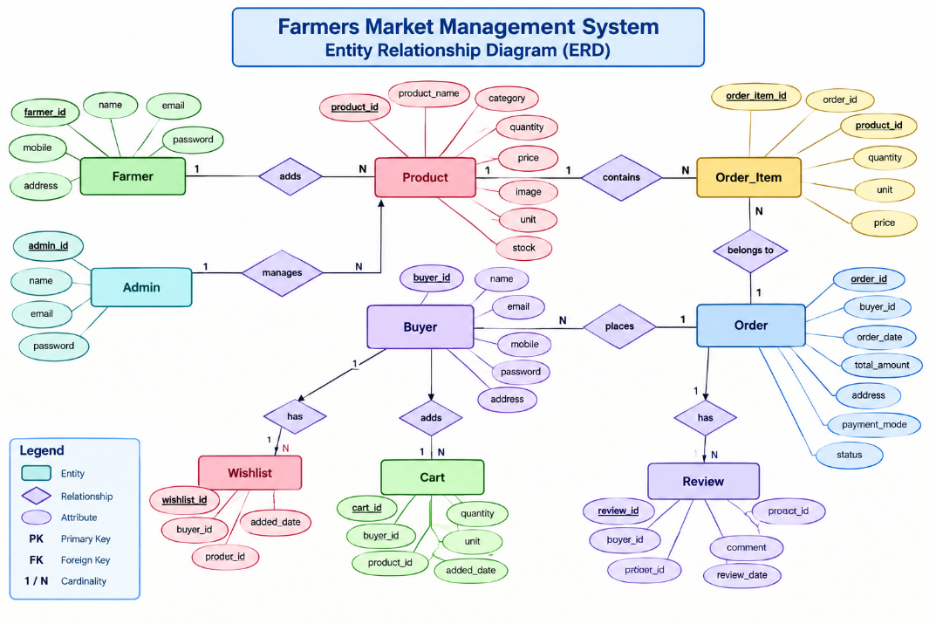
Entity Relationship Diagram

14. CRUD IMPLEMENTATION
CRUD is one of the most important parts of this project.
The SOP defines:
Operation | Meaning
Create | Add a new record
Read | Display saved records
Update | Modify an existing record
Delete | Remove a record
The expected CRUD behaviour is that a newly created record appears in the database/UI, updated values are displayed, and deleted records are removed.

14.1 CREATE OPERATION
The Create operation is implemented using the Add Product functionality.
Route:
/add_product
The farmer enters product details such as:
- Category
- Quantity
- Price
- Unit
- Stock
- Product image
After submitting the form, the product is stored in the MySQL database.
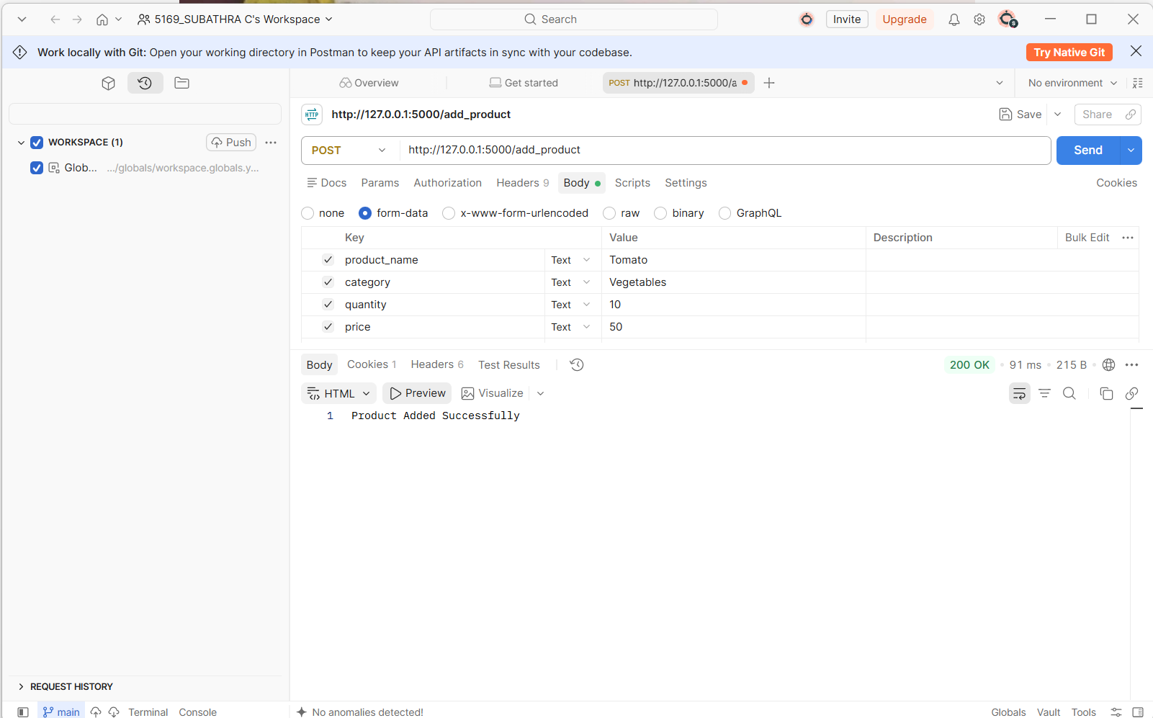
CREATE Operation – Add Product
14.2 READ OPERATION
The Read operation displays the products stored in the database.
Route:
/view_products
The application retrieves the available product records and displays them.
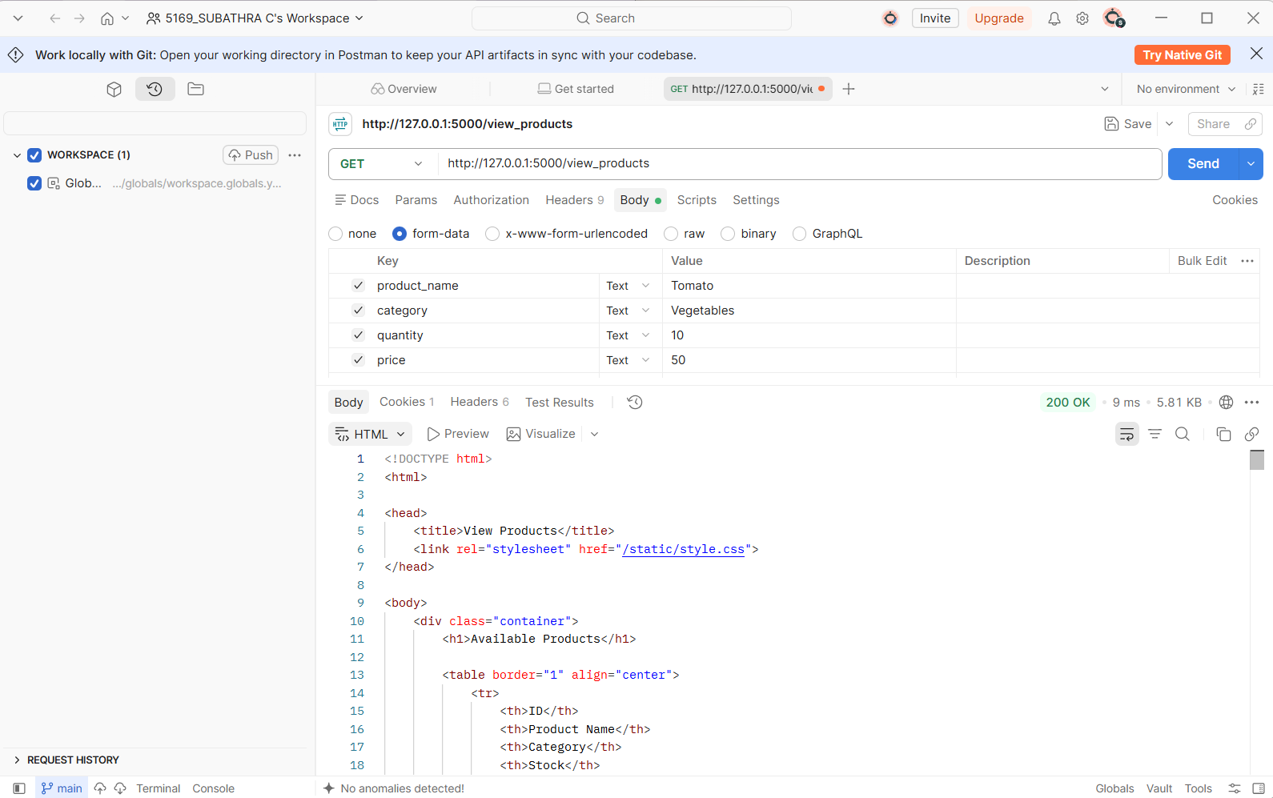READ Operation – View Products
14.3 UPDATE OPERATION
The Update operation allows existing product information to be modified.
Route:
/edit_product/<product_id>
The farmer can modify product details such as:
- Category
- Quantity
- Price
- Unit
- Stock
- Image
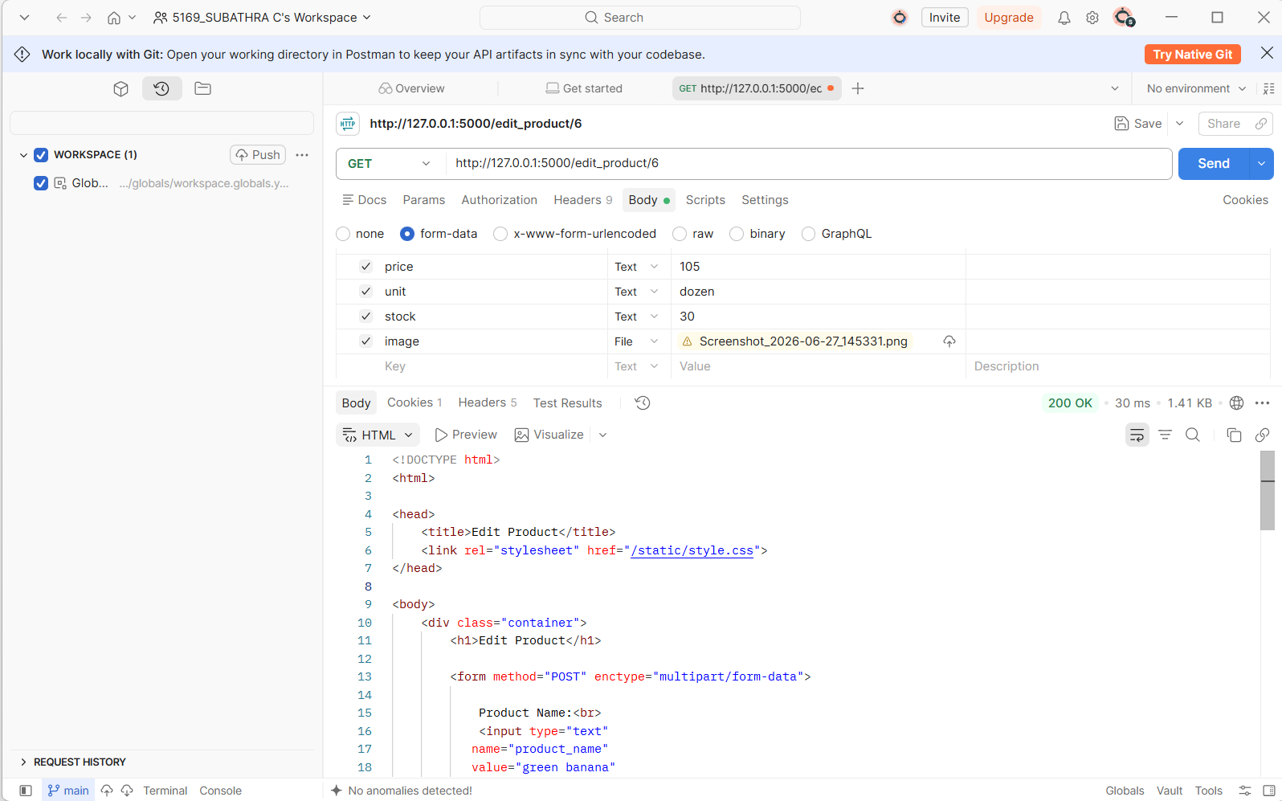
UPDATE Operation – Edit Product
14.4 DELETE OPERATION
The Delete operation removes an existing product from the database.
Route:
/delete_product/<product_id>
After deletion, the product is checked using the View Products page.
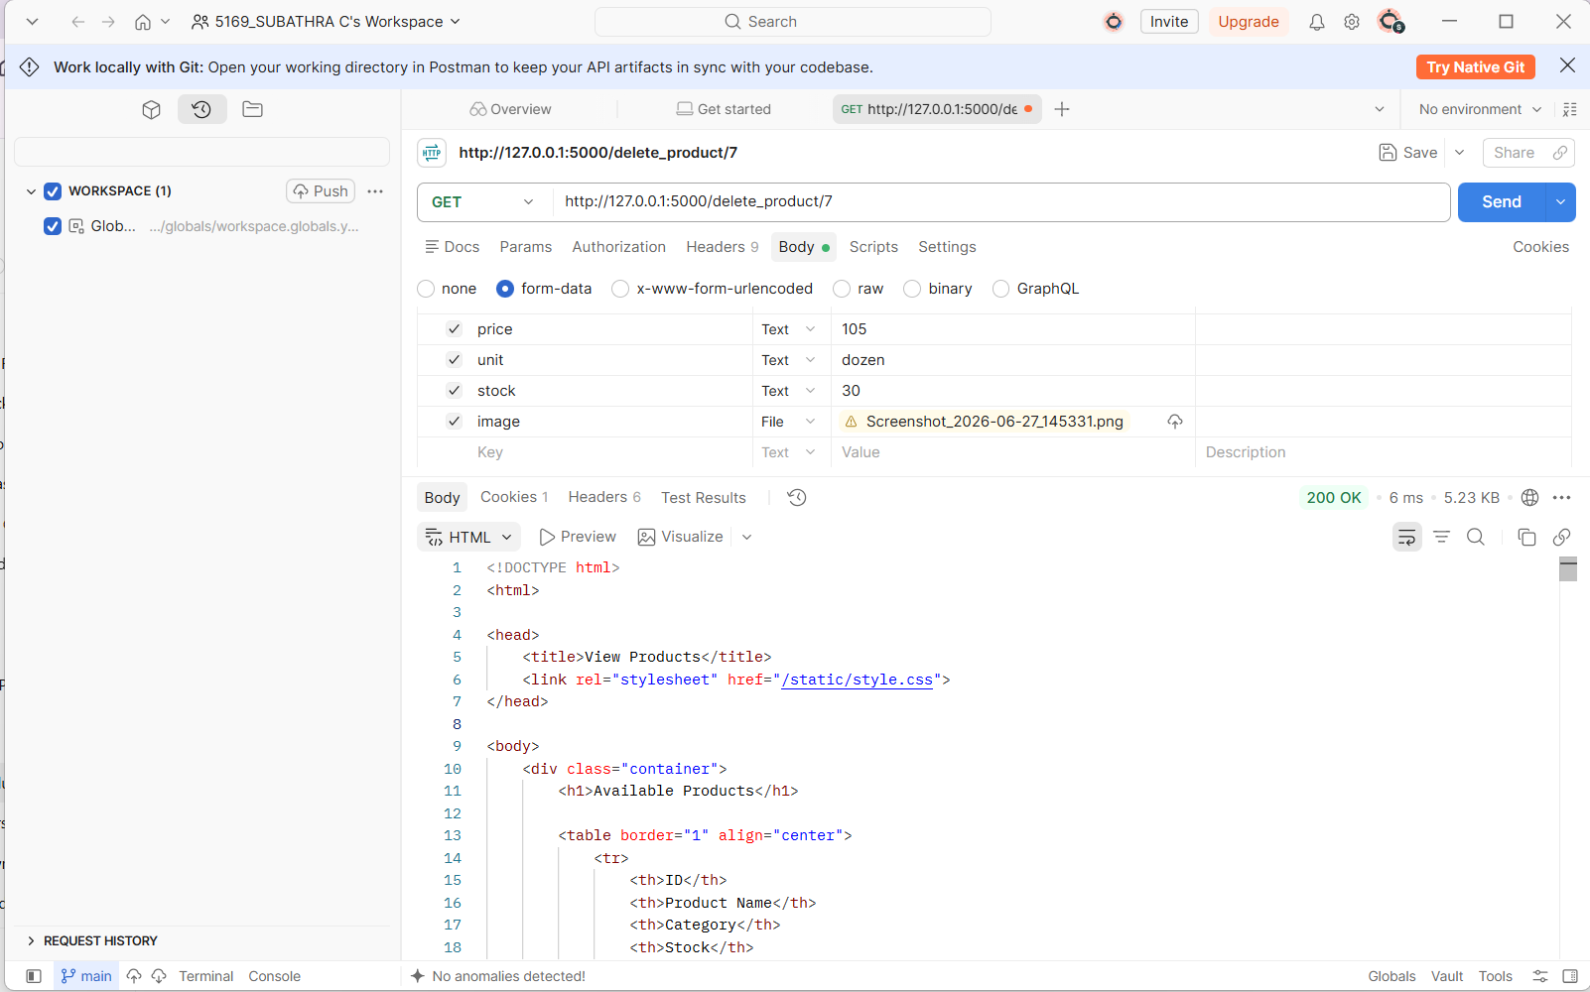
DELETE Operation – Delete Product

16. API / ROUTE DOCUMENTATION
The application contains several Flask routes for different functions.
Function | Method | Route
Home | GET | /
Farmer | GET | /farmer
Buyer | GET | /buyer
Farmer Registration | GET/POST | /farmer_register
Farmer Login | GET/POST | /farmer_login
Buyer Registration | GET/POST | /buyer_register
Buyer Login | GET/POST | /buyer_login
Admin Login | GET/POST | /admin_login
Add Product | GET/POST | /add_product
View Products | GET | /view_products
Edit Product | GET/POST | /edit_product/<product_id>
Delete Product | GET | /delete_product/<product_id>
View Orders | GET | /view_orders
Place Order | GET/POST | /place_order/<product_id>
Add to Cart | POST | /add_to_cart/<product_id>
Wishlist | GET | /wishlist
View Cart | GET | /view_cart
Checkout | GET/POST | /cart_checkout
Logout | GET | /logout

17. TESTING
Testing was performed using Postman.
The SOP recommends testing individual endpoints, checking valid/invalid data, verifying database values after operations, and testing error handling.
17.1 Test Cases
Test ID | Test Case | Method | Expected Result | Status
TC01 | Open Home Page | GET | Welcome page displayed | Pass
TC02 | Open Farmer Page | GET | Farmer page displayed | Pass
TC03 | Open Buyer Page | GET | Buyer page displayed | Pass
TC04 | Open Admin Login | GET | Login page displayed | Pass
TC05 | Farmer Registration | GET/POST | Registration form/function available | Pass
TC06 | Farmer Login | GET/POST | Farmer login processed | Pass
TC07 | Buyer Registration | GET/POST | Registration form/function available | Pass
TC08 | Buyer Login | GET/POST | Buyer login processed | Pass
TC09 | Create Product | POST | Product added | Pass
TC10 | Read Product | GET | Product displayed | Pass
TC11 | Update Product | POST | Product updated | Pass
TC12 | Delete Product | GET | Product deleted | Pass

18. VALIDATION
The application uses validation while processing user and product information.
Validation helps prevent incorrect or incomplete data from entering the system.
Examples:
- Required fields
- Email validation
- Numeric values
- Stock values
- Product information
- Login information
The SOP specifically recommends mandatory-field validation, valid email formats, appropriate numeric ranges, duplicate-value handling and server-side validation.

19. INSTALLATION AND EXECUTION
Step 1 – Install Python
Install Python and verify:
python --version
Step 2 – Install Flask
pip install flask
Step 3 – Install MySQL Connector
pip install mysql-connector-python
Step 4 – Create Database
Create the MySQL database:
CREATE DATABASE farmers_market;
Step 5 – Configure Database
Configure the database connection in the application.
Important: For the final submitted version, database passwords should not be exposed directly in a public GitHub repository. The SOP recommends environment variables for secrets and specifically says not to commit passwords or secret keys.
Step 6 – Run Flask Application
Open the project folder in VS Code and run:
python app.py
Application:
http://127.0.0.1:5000/
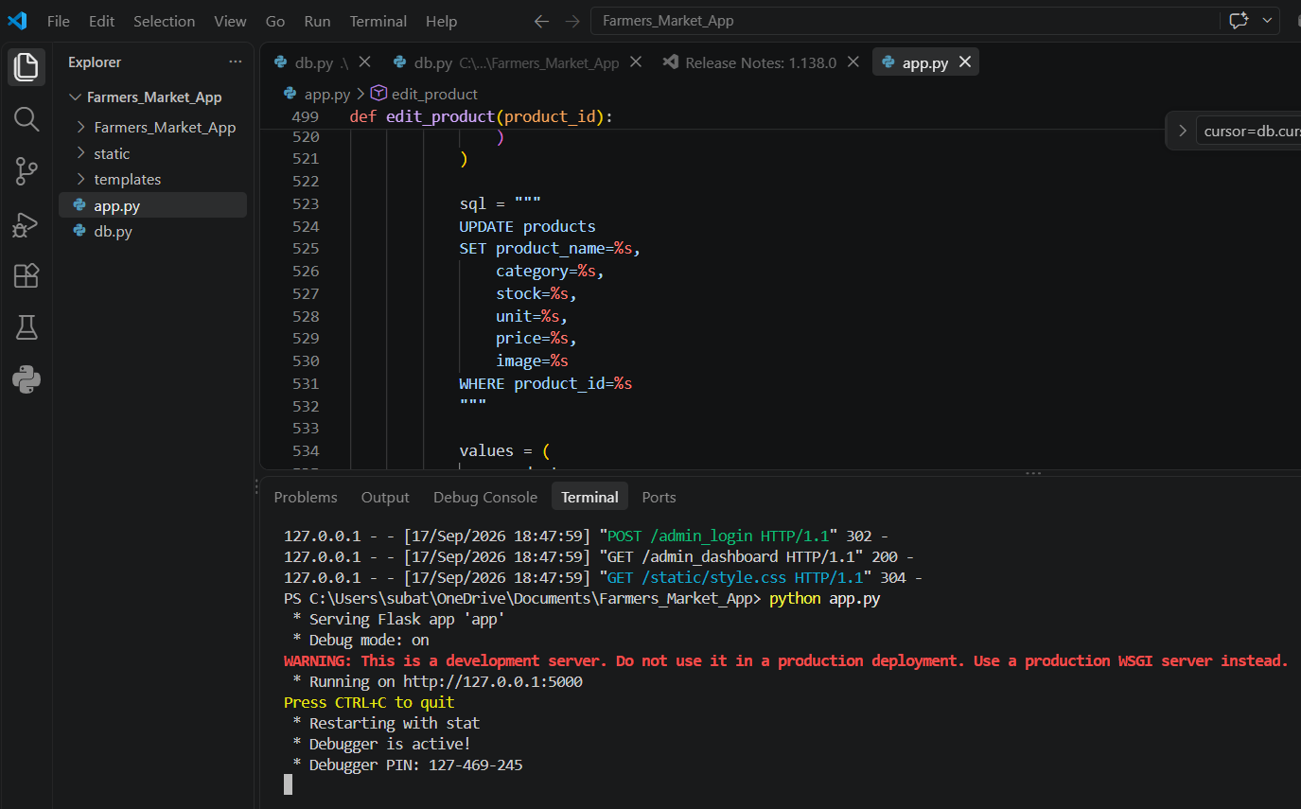
Flask Application Running Successfully

20. POSTMAN TESTING
Postman was used to test the application's HTTP routes and CRUD operations.
Testing included:
- GET requests
- POST requests
- Product creation
- Product retrieval
- Product modification
- Product deletion
The SOP identifies Postman as the API testing tool and recommends independent endpoint testing.

21. GIT AND GITHUB
Git was used for source-code version control.
The project repository is maintained on GitHub.
Repository
Farmers Market App
https://github.com/subathra-8408/Farmers_Market_App.git
Git was used to:
- Track source-code changes
- Commit modifications
- Maintain project history
- Push the project to GitHub
The SOP recommends meaningful commits and pushing the final project to the approved Git repository.

22. CHALLENGES AND SOLUTIONS
During development, several technical challenges were encountered.
Challenge 1 – Database Connection
The application required proper communication between Flask and MySQL.
Solution: MySQL Connector/Python was configured and database connectivity was verified.
Challenge 2 – Database Cursor Result Handling
Database queries caused unread-result issues during development.
Solution: Buffered database cursors were used to properly handle query results.
Challenge 3 – Product Image Upload
Product creation required image upload through the form.
Solution: Multipart form-data was used for the image upload.
Challenge 4 – Session-Based Farmer Access
Product creation required a logged-in farmer session.
Solution: Farmer login and session information were handled before accessing product management functionality.
Challenge 5 – Git Repository Management
The project contained Postman-related folders that were not required in the source repository.
Solution: .gitignore was configured to ignore .postman/ and postman/ folders.

25. CONCLUSION
The Mobile App for Direct Market Access for Farmers provides a web-based platform for managing agricultural products and connecting farmers with buyers.
The application successfully demonstrates the main CRUD operations of product management:
- Create
- Read
- Update
- Delete
It also provides farmer, buyer and administrator functionalities, product management, cart, wishlist, ordering, reviews and order management.
Python Flask provides the backend functionality while MySQL provides persistent data storage. Postman is used for testing and Git/GitHub is used for version control.
The completed project demonstrates the development of a practical full-stack CRUD-based application and provides a foundation for further enhancement and deployment.
The SOP's completion criteria similarly require all four CRUD operations, reliable frontend-backend-database communication, testing, documentation, source submission and the ability to explain the project.

